**Field Service WorkOrder Optimization**

**by**

**THAKUR ARYAN SINGH**

**singharya2004@gmail.com**

**Project Overview**

This project focuses on developing the **Field Service Work Order Optimization System**, a solution designed to address the challenge of efficiently managing and assigning work orders in dynamic field service environments.Through the use of sophisticated prioritization algorithms and an integrated database, the system pairs technicians with work orders according to proximity, availability, and skill sets. This guarantees the best possible task distribution, minimizes delays, and optimizes the use of resources.

The system includes automatic communication capabilities to further improve operations, guaranteeing that technicians receive task assignments and real-time updates on time. Furthermore, integrated analytics offer insightful information for ongoing operational enhancement. Through prompt and dependable service delivery, the initiative seeks to increase customer happiness, reduce operating costs, and improve efficiency—all of which will contribute to long-term business growth .

**Objectives**

**Business Goals**

1. Optimize the assignment of work orders to ensure a seamless workflow. This improves coordination between tasks and reduces delays in service delivery. By enhancing operational efficiency, the system ensures better resource management.
2. Ensure timely task allocation and service delivery to meet customer expectations. Transparent communication keeps customers informed throughout the process. These improvements lead to a better overall customer experience.
3. Reduce operational costs by improving resource utilization and minimizing idle time.

**Specific Outcomes**

1. Design a system to match work orders with technicians based on:
   * **Location**
   * **Sevice type**
   * **Skills**
2. Implement a prioritization algorithm to ensure high-priority tasks are assigned effectively.
3. Automate communication processes to keep technicians informed about their assignments.
4. Provide robust analytics and actionable insights to support continuous improvement in field service operations.

**Salesforce Key Features and Concepts Utilized**

1. Custom Objects and Fields
2. Automated Processes
3. Reports and Dashboards
4. Role-Based Access Control
5. Lightning Experience
6. Data Import and Export
7. Email Integration
8. Formulas and Validation Rules
9. Analytics and Insights
10. Integration with External Systems

**Detailed Steps to Solution Design**

**Custom Objects Created**

* **Technician Object**: The Technician object was created to store detailed information about technicians such as their name, skills, availability, phone number, and location. The technician details were imported from a Technician.csv file, enabling efficient assignment of tasks based on these attributes.

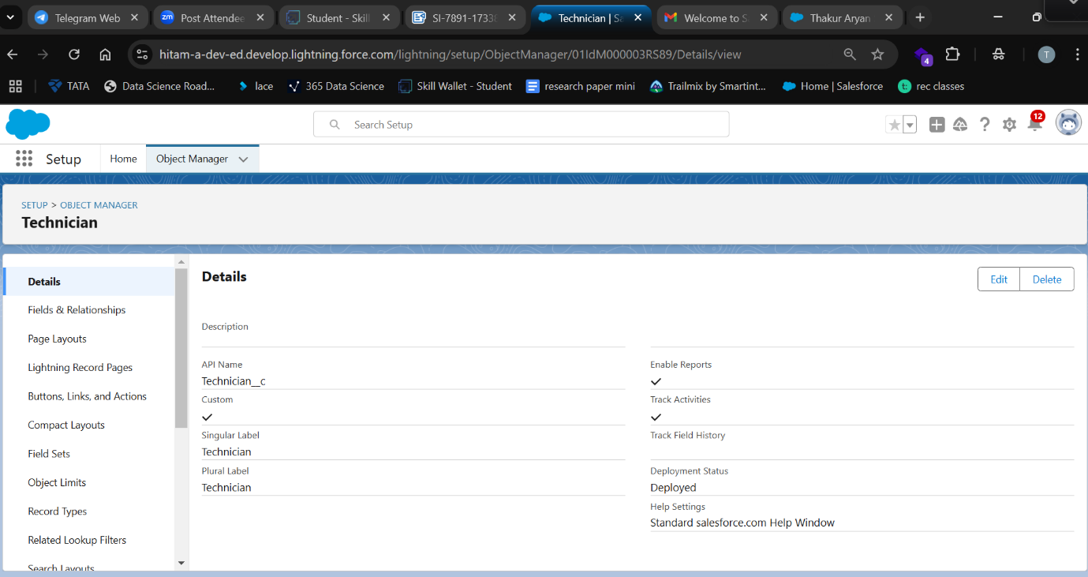

* **WorkOrder Object**: This object was developed to manage and track work orders assigned to field technicians. It includes key fields such as priority, service type, and location, ensuring comprehensive management of each work order throughout its lifecycle.

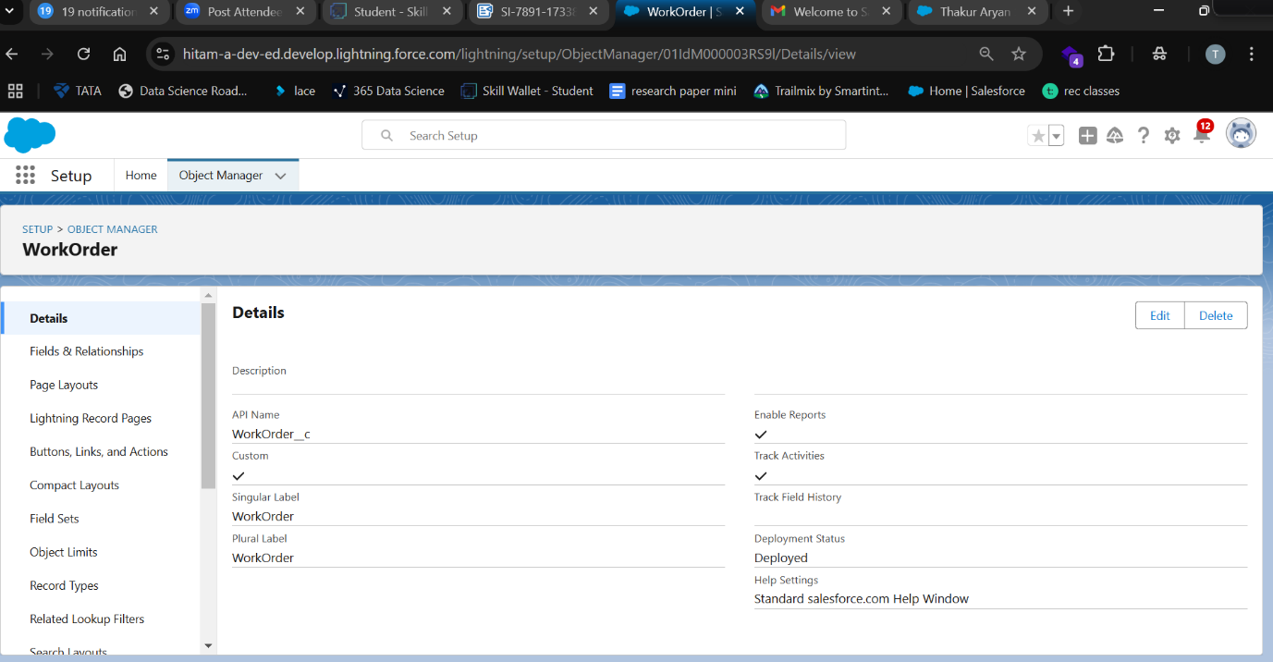

* **Assignment Object**: The Assignment object was introduced to facilitate the management of work orders assigned to technicians. It includes fields like Technician ID, Assignment Date, and Completion Date, ensuring effective tracking of the work assigned and completed by each technician.

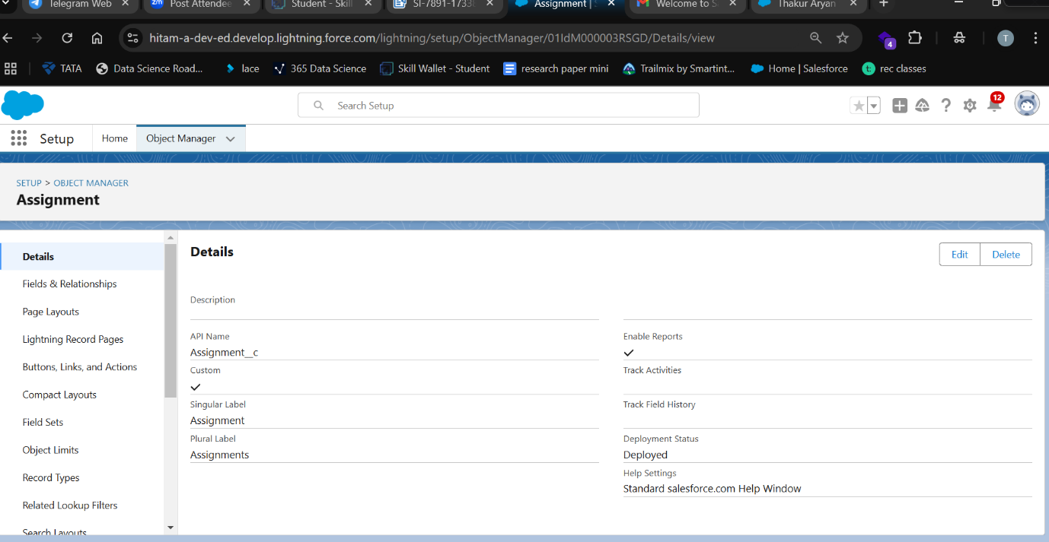

**Custom Fields and Relationships**

* **Assignment Object**:
  + *Lookup Field*: A lookup field was created to associate each assignment with a specific WorkOrder object, linking work orders to their respective assignments.
  + *Formula Fields*: Formula fields were implemented to calculate important dates (e.g., completion date) and track status updates based on the related records for improved tracking and reporting.
* **WorkOrder Object**:
  + *Picklist Values*: Picklist values were added to fields like Priority and Service Type to maintain standardization and consistency in the data.
  + *Formula Fields*: Formula fields were added to calculate the creation dates and track the status updates automatically, improving data accuracy and streamlining the reporting process.

**Tabs and Navigation**

* **Custom Tabs**: A custom tab for the Assignment object was created, ensuring users can easily access assignment records from the Salesforce interface.
* **Navigation**: Relevant items such as Home, WorkOrder, Technician, Assignment, Reports, and Dashboard were added to the Lightning App, providing quick and easy access to the main features of the app for users.

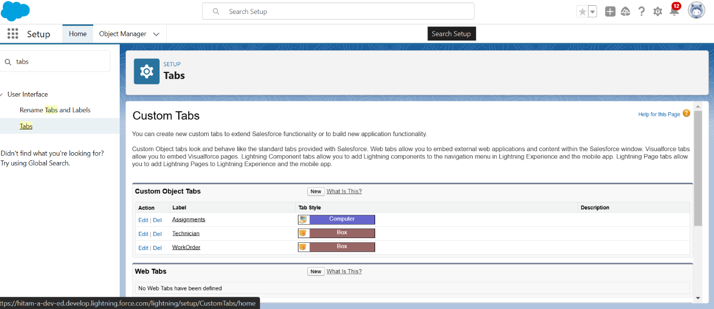

**Lightning App Creation**

* **App Name**: The Lightning App was named "Field Service WorkOrder Optimization" to align with the project’s objective of optimizing work order management for field technicians.
* **Navigation Items**: The app includes essential navigation items such as Home, WorkOrder, Technician, Assignment, Reports, and Dashboard, ensuring that users can quickly access the required functionality for day-to-day operations.
* **User Profiles**: Access to the app was granted to the System Administrator profile, ensuring full visibility and control over the app’s configuration and records. Additional profiles can be configured based on role-based access to control data visibility.

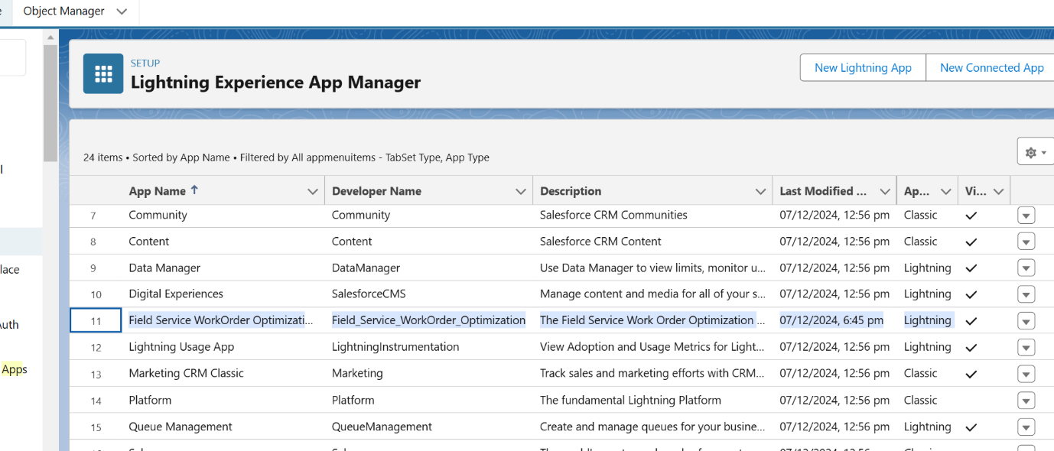

**Fields & Relationship**

* **Creating Lookup Field in Assignment Object (WorkOrder, Technician ID)**:  
  A Lookup field was created to link the Assignment object with the WorkOrder and Technician objects. This helps track work orders and technician assignments efficiently.
* **Creating Formula Fields in Assignment Object (Assignment Date, Completion Date)**:  
  Formula fields for Assignment Date and Completion Date were created to automatically calculate and track the relevant dates. This reduces manual data entry and ensures accurate and consistent date tracking.
* **Manage Your Picklist Values (Location, Priority, Service Type) in WorkOrder Object**:  
  Picklist values were configured for fields like Location, Priority, and Service Type in the WorkOrder object. This standardizes data entry and enhances reporting consistency.
* **Creating Formula Field in WorkOrder Object (Date)**:  
  A formula field was implemented to automatically capture and display the creation or modification date of the work order. This ensures accurate timestamping without manual entry.

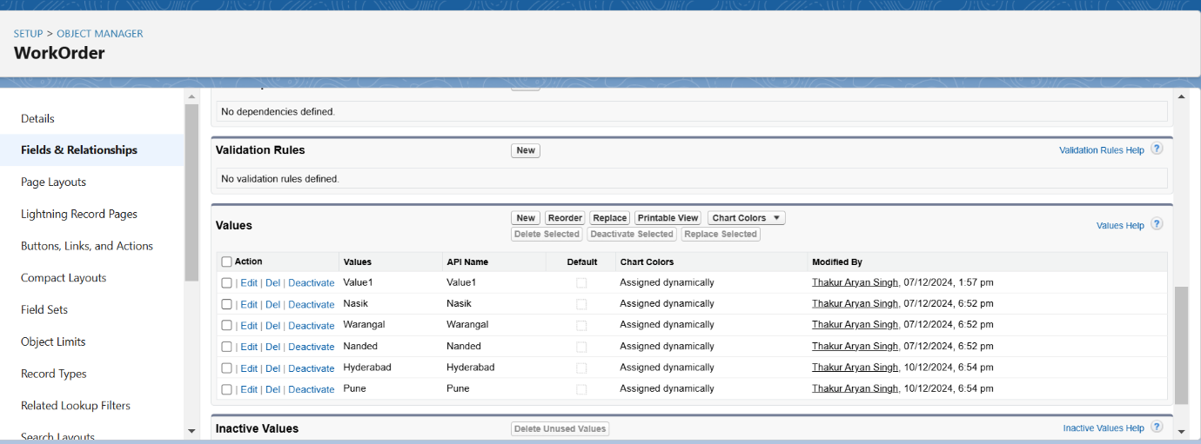

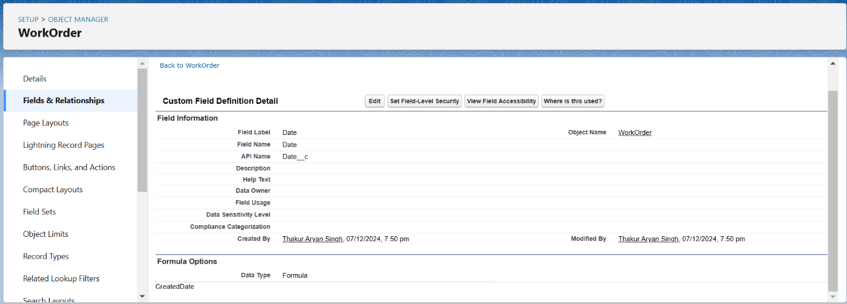

**Manage your picklist values**

In the WorkOrder object, the following values are added to the respective fields:

* For the **Priority** field, the value "High" is included.
* The **Service Type** field includes the values "Hardware repair," "Troubleshoot/Debugging," and "Lane-Management."

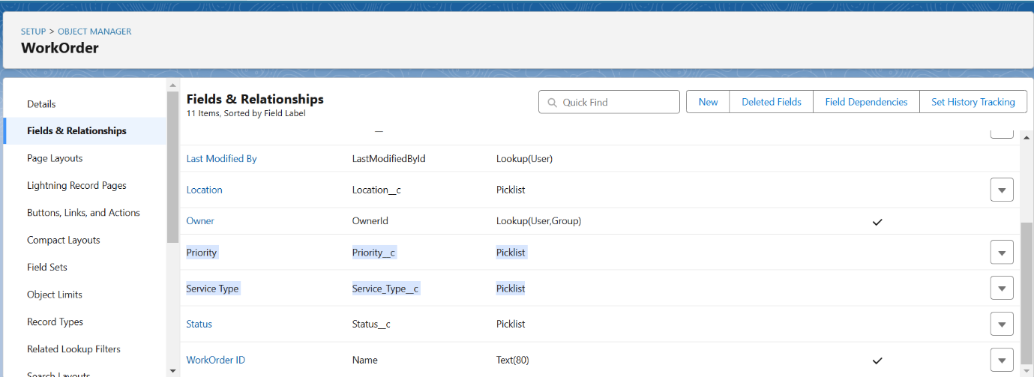

To create the remaining fields for the respective objects, follow the data types outlined in the table. For the **Assignment** object, create the following fields:

1. **Technician ID**: Use the Lookup data type and link it to the **Technician** object.
2. **Assignment Date**: Use a Formula field with a return type of Date. The formula should reference**WorkOrder_ID__r.Date__c.**
3. **Completion Date**: Use a Formula field with a return type of Date. The formula should check if the **WorkOrder_ID__r.Status__c** is 'Resolved' and return the **WorkOrder_ID__r.LastModifiedDate**; otherwise, return NULL.

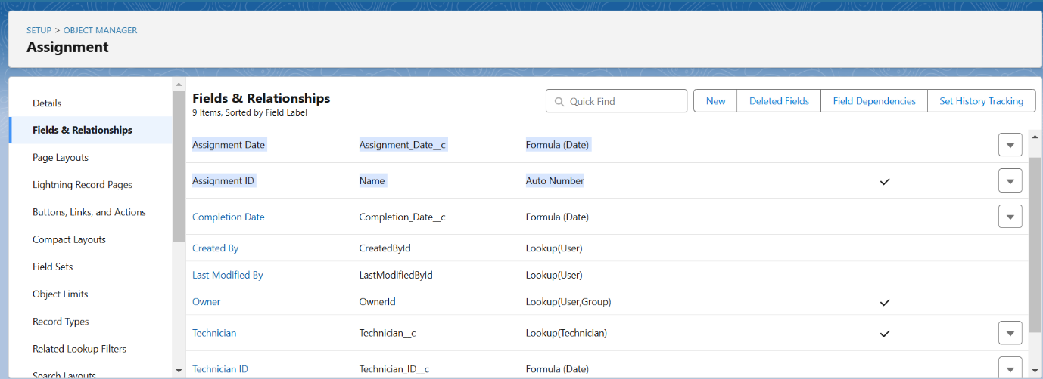

**Profiles**

**Technician Profile**: The Technician profile was configured with Read-Only access to the **Technician**, **WorkOrder**, and **Assignment** objects. Critical fields, such as **Status** in the **WorkOrder** object, were made visible by adjusting field-level security settings to ensure the technician can access essential information.

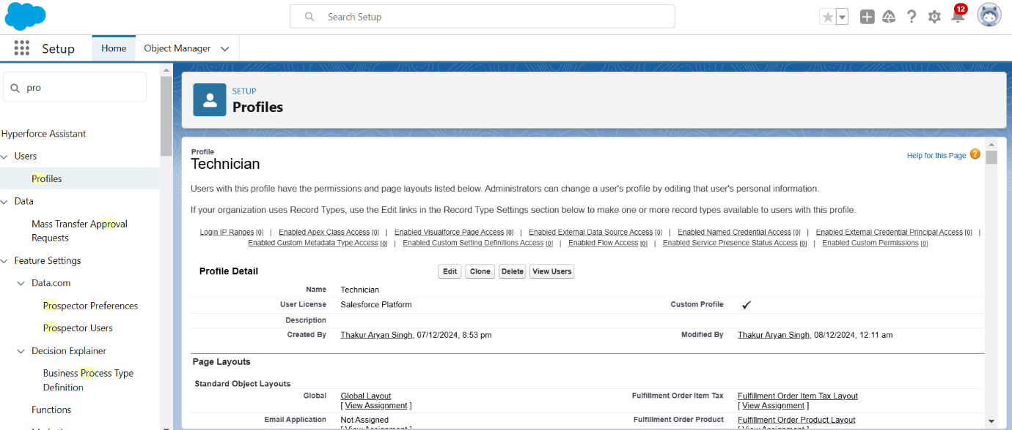

**User Creation**: A user named "Elina Gilbert"was created under the **Technician** profile, which included relevant personal details. The user was assigned a **Salesforce Platform license**, granting access to the necessary platform features for the technician's role.

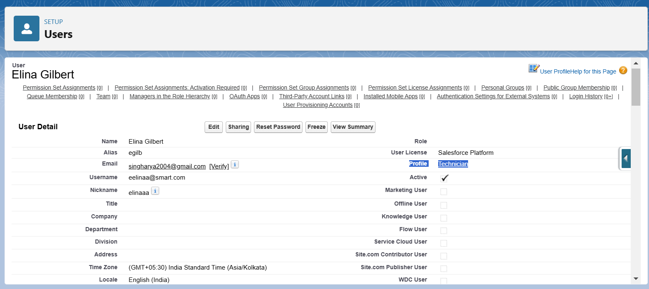

**Testing and Validation**

**Unit Testing (Apex Classes, Triggers)**

Deploy the following Apex classes and triggers using the Salesforce Developer Console or Salesforce CLI:

**Apex Classes**:

* WorkOrderClass
* AssigningEmailClass
* CompletionMailClass
* RecordDeletionClass
* ScheduleClass

**Apex Triggers**:

* WorkOrderTrigger
* AssignmentTrigger

**NOTE**: The codes are available in my github repository named "**Field-Service-WorkOrder-Optimization**"

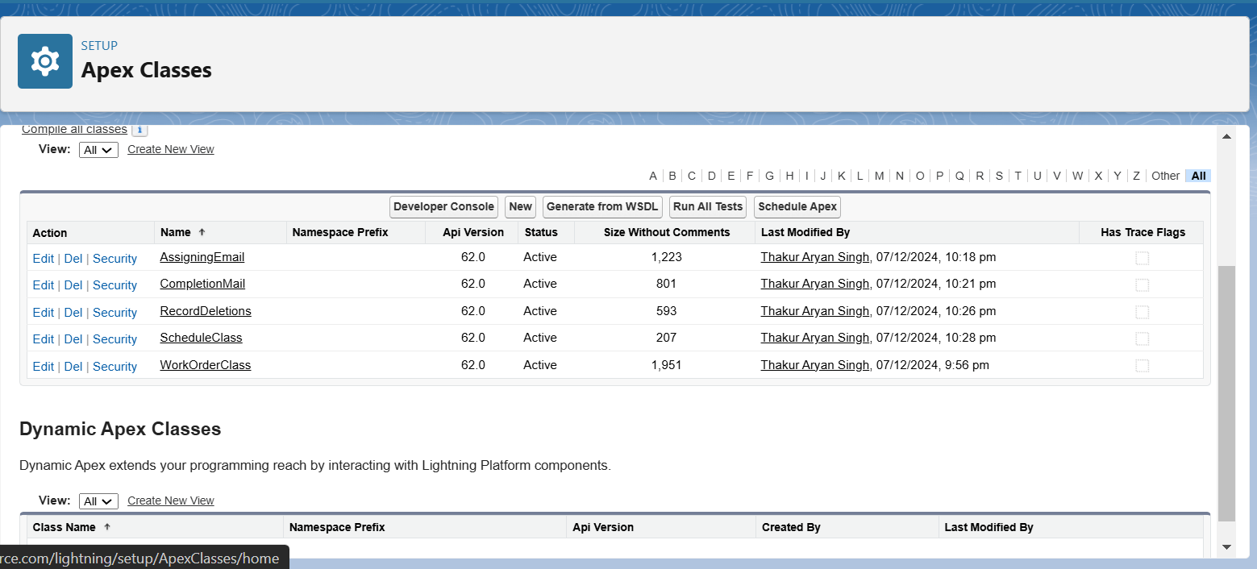

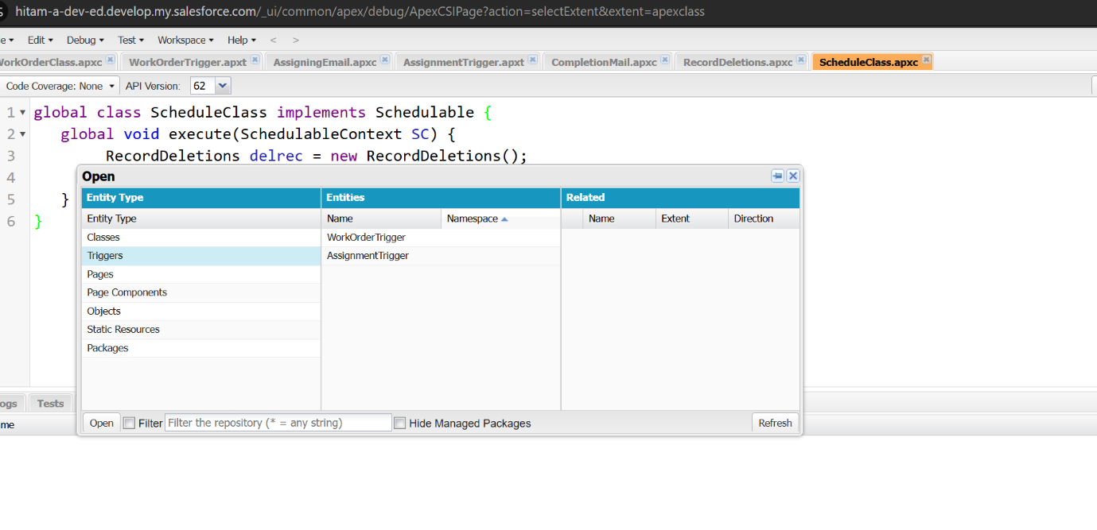

**Reports & Dashboards**  
Salesforce Reports and Dashboards allow users to analyze and visualize data, helping businesses gain insights, track performance, and make informed decisions.

**Create Reports**

* **Assignment with WorkOrder ID Report**: Create a report that includes assignments linked to their respective WorkOrder IDs.
* **WorkOrders Status Reports**: Create a report to track and analyze the statuses of work orders.
* **Technician and Assignment Details Reports**: Generate a report that includes detailed information about technicians and their assigned tasks.

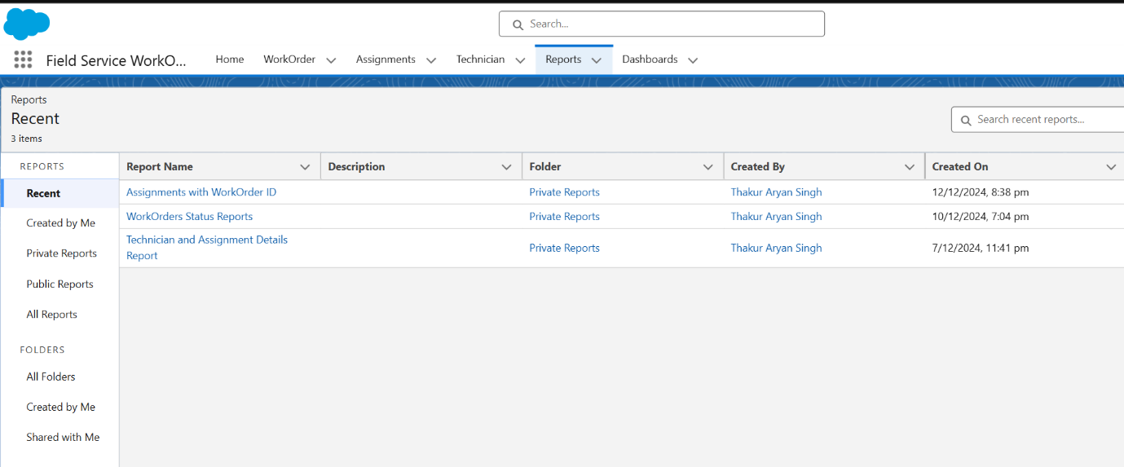

**Create Dashboards**  
Create a dashboard that displays the completed work order statuses in a vertical bar graph, using the data from reports on work order completion. This dashboard will provide a clear visualization of completed work orders, showing trends and performance based on the work order status.

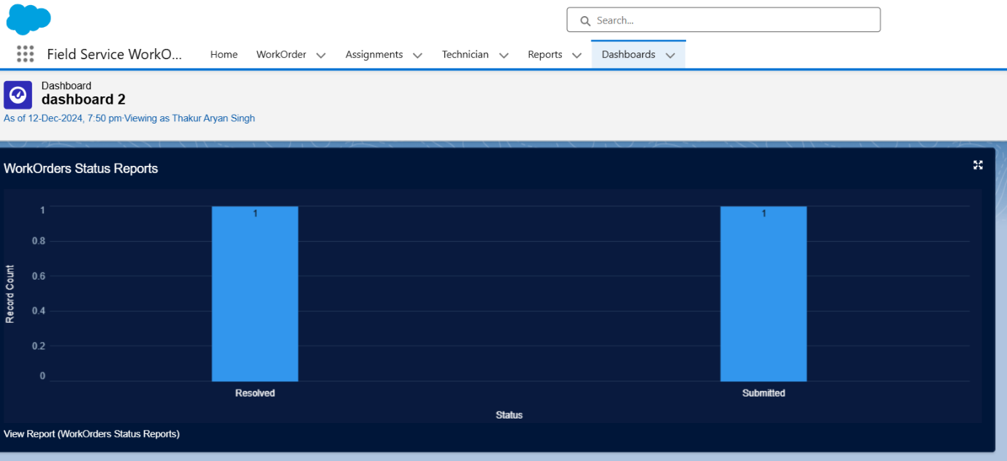

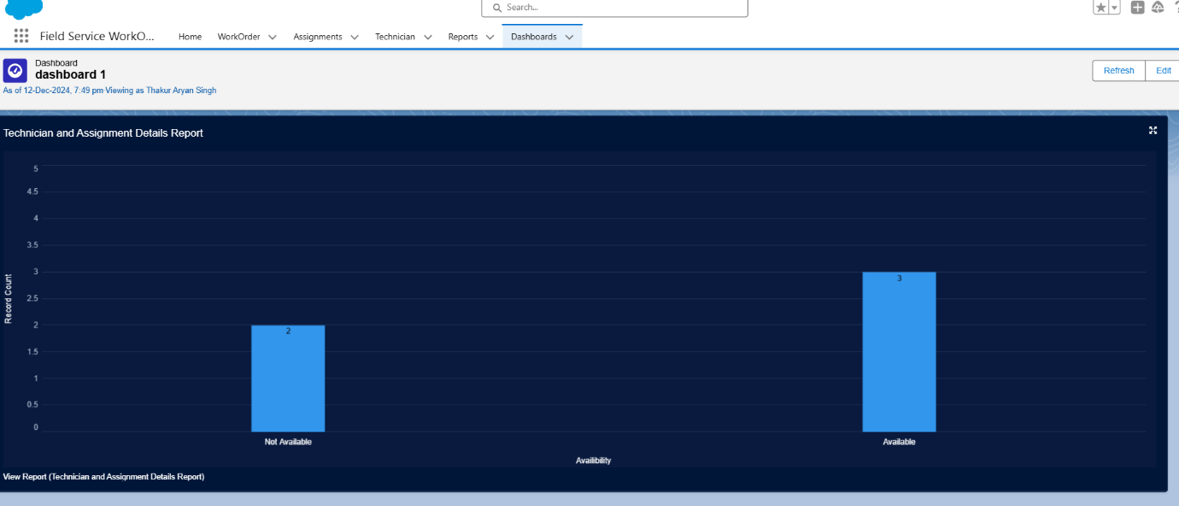

**Key Scenarios Addressed by Salesforce in the Implementation Project:**

* Efficient work order assignment
* Real-time tracking and updates
* Centralized data management
* Performance analytics
* Enhanced customer satisfaction
* Cost reduction

**Conclusion**

The Field Service WorkOrder Optimization project successfully deployed a Salesforce-based solution to streamline field service management. Key achievements include the creation of custom objects like Technician, WorkOrder, and Assignment, along with automated processes for assigning tasks to technicians based on their skills, availability, and location. Additionally, real-time reporting and dashboards were implemented, offering valuable insights into work order status and technician performance. These improvements have resulted in enhanced operational efficiency, reduced costs, and increased customer satisfaction.